Creating Headings in Word – A Quick Summary
Most text editors offer two methods of visually styling information but only one method actually provides structural content.
Unfortunately the method that does not provide structured information is often seems the closest at hand making your editor work against your goal of creating accessible content.

What method NOT to use for text formatting
The most obvious menus available to you in Word for formatting text are the Font section of the Home Menu.
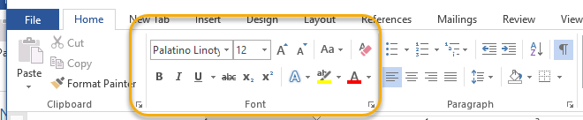
And the first part of the Context sensitive menu that comes up when you right-click the mouse at your cursor location.
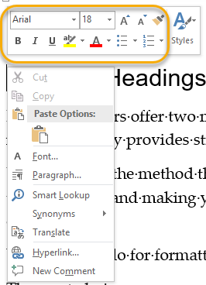
These two menus will definitely format your text but it will not build any structural information into your text.

Styles - the method to use for accessible text formatting
To provide both visual formatting and structured content you need to use the Styles menu.

Accessing the Styles Menu
It can be accessed in two locations.

Styles section on Home Tab
If you go further to the right along the Home menu you will come to the styles Block.

Styles section on Right-click context menu.
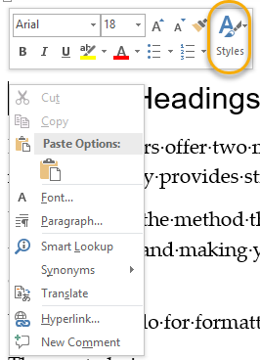

Using the Styles Menu

Technique one: select style before typing
Styles can be font level, paragraph level and both font and paragraph level formatting. Headings fall into this latter category. When you click a style it will convert all the text in the current paragraph to that type of formatting. The formatting will continue until a new style is selected.

Technique two: add style after typing
You can click a Heading style at any time in a paragraph and it will apply immediately to the whole paragraph since the Heading style applies both to font and paragraph levels.

Applying Heading Styles
Headings need to be applied logically for them to convey information. Lower headings should be nested within higher level headings and indicate sub-topics within the higher level. Headings also be always used sequentially.
Here is an example what properly structured document might show for headings. You will notice that if you are looking at headings that the text formatting implies level of information. Top level should have the largest most obvious font with diminishing visual importance on page.
Heading Level 1
Heading Level 2
Heading Level 3
Heading Level 4
Heading Level 3
Heading Level 4
Heading Level 2
Heading Level 3
Heading Level 3
Heading Level 4
Here is an example of a poorly structured document. The uneven heading levels make it very difficult to understand the information.
Heading Level 1
Heading Level 3
Heading Level 2
Heading Level 4
Heading Level 3
Heading Level 1
Heading Level 4

Checking your document Heading Structure
Word offers a couple of easy ways to determine if you are using headings correctly.

Method 1: View in Navigation Pane
Turn on the Navigation Pane by going to View Tab on Ribbon and selection Navigation Pane
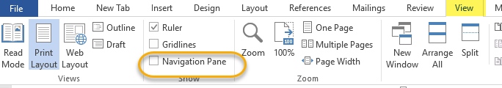
Selecting Navigation Pane will result in a new screen area to appear on the left side of your document. The navigation pane allows you to do a number of different tasks but when Headings are selected then it will show headings within the current document. As this document is constructed purely with text formatting no headings appear! And because no styles are being used I am probably making formatting errors so when I mean to switch topic level the visual cues I am giving are not correct.
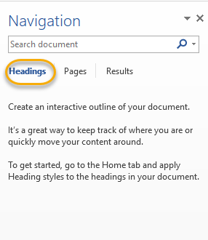

Method 2: View in Outline Mode (Advanced Technique)
View your document in Outline Mode by selecting Outline Mode on View tab.
Outline mode is made for both viewing structure and efficient reorganizing documents.
It is beyond the scope of this document but if you do any significant document creation you should be come familiar with its features.
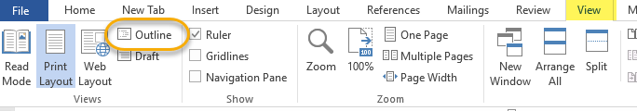

Changing the way Headings look
Headings often get misused because it is obvious that they will style text but choices are being made purely on appearance and not on a structural basis.
You can easily change how the headings look in your document.
Before starting to adjust styles it is best to open Styles Pane. You can do this by clicking small expand arrow in bottom right corner of Styles section in ribbon.
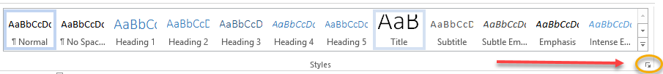
This will open up a pane on the right side of your document (default position) that will look something like image below.
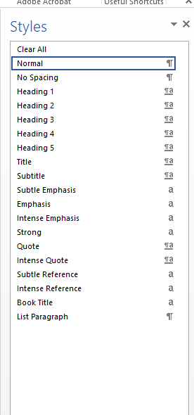
Use the Font and Paragraph menus to style your text to the way you want them to look (yes you now get to you them!).
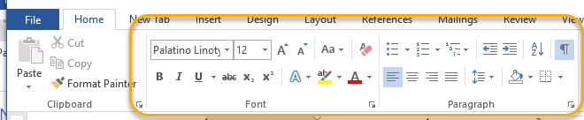

You can either pick your font and paragraph settings before you type or you can select then format. Make sure that text has been ended with a hard line break (Enter Key used at end not Shift-Enter)
For Example I want my Level 1 Heading to look like this sentence.
- Select text.
- Go to Style Pane and hover on left side of Style you want to change until small arrow appears, in my case it would be Heading 1. Click small arrow.
- Select Update
- You should now see updated style in the Styles section of ribbon. You can do that for every style you want to adjust.
Note: If you wanted to add a new style you can do so at bottom of Styles pane, there is an add Styles button there.
