Creating Headings in Word – A Quick Summary
Most text editors offer two methods of visually styling information but only one method actually provides structural content.
Unfortunately the method that does not provide structured information is often seems the closest at hand making your editor work against your goal of creating accessible content.
What method NOT to use for text formatting
The most obvious menus available to you in Word for formatting text are the Font section of the Home Menu.
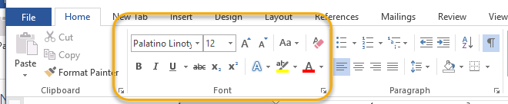
And the first part of the Context sensitive menu that comes up when you right-click the mouse at your cursor location.
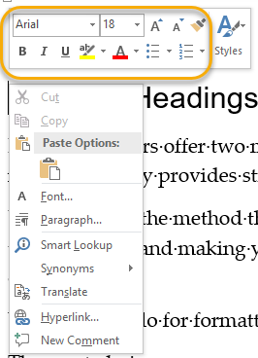
These two menus will definitely format your text but it will not build any structural information into your text.
Styles - the method to use for accessible text formatting
To provide both visual formatting and structured content you need to use the Styles menu.
Accessing the Styles Menu
It can be accessed in two locations.
Styles section on Home Tab
If you go further to the right along the Home menu you will come to the styles Block.
Styles section on Right-click context menu.
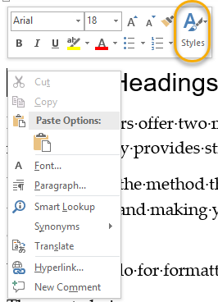
Using the Styles Menu
Technique one: select style before typing
Styles can be font level, paragraph level and both font and paragraph level formatting. Headings fall into this latter category. When you click a style it will convert all the text in the current paragraph to that type of formatting. The formatting will continue until a new style is selected.
Technique two: add style after typing
You can click a Heading style at any time in a paragraph and it will apply immediately to the whole paragraph since the Heading style applies both to font and paragraph levels.

